Nama : Zahir Abdul Rasyid

NRP : 1152000047

PBO TUGAS 2

Code :

**import** random

**import** os

class Hero:

**def** __init__(*self*, **nama**, **basicAttack**, **hp**, **skill**, **pasif**):

*self*.nama **=** nama

*self*.basicAttack **=** int(basicAttack)

*self*.hp **=** int(hp)

*self*.skill **=** skill

*self*.pasif **=** pasif

*self*.item **=** []

**def** tambahItem(*self*, **item**):

*self*.item.append(item)

class Magical(*Hero*):

**def** __init__(*self*, **nama**, **basicAttack**, **hp**, **skill**, **magicPower**, **physicalDef**, **pasif**):

*self*.magicPower **=** int(magicPower)

*self*.physicalDef **=** int(physicalDef)

        super().__init__(nama, basicAttack, hp, skill, pasif)

class Physical(*Hero*):

**def** __init__(*self*, **nama**, **basicAttack**, **hp**, **skill**, **physicalAttack**, **magicDefense**, **pasif**):

*self*.physicalAttack **=** int(physicalAttack)

*self*.magicDefense **=** int(magicDefense)

        super().__init__(nama, basicAttack, hp, skill, pasif)

class Item:

**def** __init__(*self*, **nama**, **damage**):

*self*.nama **=** nama

*self*.damage **=** int(damage)

class Skill:

**def** __init__(*self*, **nama**, **attack**, **defense**):

*self*.nama **=** nama

*self*.attack **=** int(attack)

*self*.defense **=** int(defense)

mysticGush **=** Skill("Mystic Gush", 10, 80)

deadlyMagic **=** Skill("Deadly Magic", 20, 70)

orderNchaos **=** Skill("Order & Chaos", 30, 60)

violetReqiem **=** Skill("Violet Reqiem", 40, 50)

zamanForce **=** Skill("Zaman Force", 40, 50)

vegeaneFlame **=** Skill("Vegeane Flame", 60, 30)

featheredAirStrike **=** Skill("Fearhered Air Strike", 70, 20)

bastFeast **=** Skill("Bats Feast", 80, 10)

tripleSweep **=** Skill("Triple Sweep", 20, 10)

alecto **=** Skill("Alecto : Final Blow", 30, 15)

theWayofDragon **=** Skill("The Way of Dragon", 40, 20)

pasif **=** Skill("Pasif", 200, 0)

gord **=** Magical("Gord", 100, 800, mysticGush, 100, 100, 0)

harley **=** Magical("Harley", 100, 700, deadlyMagic, 200, 200, 0)

lunox **=** Magical("Lunox", 100, 600, orderNchaos, 300, 300, pasif)

guinevere **=** Magical("Guinevere", 100, 500, violetReqiem, 400, 400, 0)

harith **=** Magical("Harith", 100, 400, zamanForce, 500, 500, 0)

valir **=** Magical("Valir", 100, 300, vegeaneFlame, 600, 600, 0)

pharsa **=** Magical("Pharsa", 100, 200, featheredAirStrike, 700, 700, pasif)

cecillion **=** Magical("Cecillion", 100, 100, bastFeast, 800, 800, 0)

saveHeroMagic **=** [gord, harley, lunox, guinevere, harith, valir, pharsa, cecillion]

saber **=** Physical("Saber", 100, 400, tripleSweep, 400, 400, pasif)

benedetta **=** Physical("Benedetta", 100, 300, alecto, 500, 500, pasif)

chou **=** Physical("Chou", 100, 500, theWayofDragon, 40, 20, pasif)

heroRandomMagic1 **=** (random.choice(saveHeroMagic))

heroRandomMagic2 **=** (random.choice(saveHeroMagic))

heroRandomMagic3 **=** (random.choice(saveHeroMagic))

saveNamaHeroMagic1 **=** heroRandomMagic1.nama

saveNamaHeroMagic2 **=** heroRandomMagic2.nama

saveNamaHeroMagic3 **=** heroRandomMagic3.nama

saveheroMagicRandom1 **=** heroRandomMagic1

saveheroMagicRandom2 **=** heroRandomMagic2

saveheroMagicRandom3 **=** heroRandomMagic3

saveItem **=** []

**def** menu1():

    print(f'''

#########

Daftar nama hero magic

$$$$$$$$$

{gord.nama}

{harley.nama}

{lunox.nama}

{guinevere.nama}

{harith.nama}

{valir.nama}

{pharsa.nama}

{cecillion.nama}

#########

''')

    os.system('pause')

**def** menu2():

    print(f'''

#########

Daftar nama hero physical

$$$$$$$$$

{saber.nama}

{benedetta.nama}

{chou.nama}

#########

''')

    os.system('pause')

**def** menu3():

    print(f'''

#########

Daftar nama skill hero magic

$$$$$$$$$

{gord.nama} memiliki skill {gord.skill.nama}

{harley.nama} memiliki skill {harley.skill.nama}

{lunox.nama} memiliki skill {lunox.skill.nama}

{lunox.nama} memiliki skill {pasif.nama}

{guinevere.nama} memiliki skill {guinevere.skill.nama}

{harith.nama} memiliki skill {harith.skill.nama}

{valir.nama} memiliki skill {valir.skill.nama}

{pharsa.nama} memiliki skill {pharsa.skill.nama}

{pharsa.nama} memiliki skill {pasif.nama}

{cecillion.nama} memiliki skill {cecillion.skill.nama}

#########

''')

    os.system('pause')

**def** menu4():

    print(f'''

#########

Daftar nama skill hero physical

$$$$$$$$$

{saber.nama} memiliki skill {saber.skill.nama}

{saber.nama} memiliki skill {pasif.nama}

{benedetta.nama} memiliki skill {benedetta.skill.nama}

{saber.nama} memiliki skill {pasif.nama}

{chou.nama} memiliki skill {chou.skill.nama}

{saber.nama} memiliki skill {pasif.nama}

#########

''')

    os.system('pause')

**def** menu5():

    print(f'''

3 Magic VS 3 Physical

{saveNamaHeroMagic1}

VS

{saber.nama}

3 Magic VS 3 Physical

{saveNamaHeroMagic2}

VS

{benedetta.nama}

3 Magic VS 3 Physical

{saveNamaHeroMagic3}

VS

{chou.nama}''')

    os.system('pause')

    print('''

Buat item dan tambahkan kepada hero

Membuat beberapa objek item sampai berhenti''')

    i **=** 1

**while** True:

        print(f"Item ke- {i}")

        masukanItem **=** input("Masukan atribut item / berhenti : ")

**if** masukanItem **==** "berhenti":

**break**

**else**:

            listMasukan **=** masukanItem.split("#")

            saveItem.append(Item(listMasukan[0], listMasukan[1]))

            i **+=** 1

*global* randomItem1

*global* randomItem2

*global* randomItem3

*global* randomItem4

*global* randomItem5

*global* randomItem6

    randomItem1 **=** (random.choice(saveItem))

    randomItem2 **=** (random.choice(saveItem))

    randomItem3 **=** (random.choice(saveItem))

    randomItem4 **=** (random.choice(saveItem))

    randomItem5 **=** (random.choice(saveItem))

    randomItem6 **=** (random.choice(saveItem))

*global* saveRandomItem1

*global* saveRandomItem2

*global* saveRandomItem3

*global* saveRandomItem4

*global* saveRandomItem5

*global* saveRandomItem6

    saveRandomItem1 **=** randomItem1

    saveRandomItem2 **=** randomItem2

    saveRandomItem3 **=** randomItem3

    saveRandomItem4 **=** randomItem4

    saveRandomItem5 **=** randomItem5

    saveRandomItem6 **=** randomItem6

*global* saveNamarandomItem1

*global* saveNamarandomItem2

*global* saveNamarandomItem3

*global* saveNamarandomItem4

*global* saveNamarandomItem5

*global* saveNamarandomItem6

    saveNamarandomItem1 **=** randomItem1.nama

    saveNamarandomItem2 **=** randomItem2.nama

    saveNamarandomItem3 **=** randomItem3.nama

    saveNamarandomItem4 **=** randomItem4.nama

    saveNamarandomItem5 **=** randomItem5.nama

    saveNamarandomItem6 **=** randomItem6.nama

**def** menu6():

    print(f'''

Hero beli item

{saveNamaHeroMagic1} membeli item {saveNamarandomItem1}

{saveNamaHeroMagic2} membeli item {saveNamarandomItem2}

{saveNamaHeroMagic3} membeli item {saveNamarandomItem3}

{saber.nama} membeli item {saveNamarandomItem4}

{benedetta.nama} membeli item {saveNamarandomItem5}

{chou.nama} membeli item {saveNamarandomItem6}

''')

    saveheroMagicRandom1.tambahItem(saveRandomItem1)

    saveheroMagicRandom2.tambahItem(saveRandomItem2)

    saveheroMagicRandom3.tambahItem(saveRandomItem3)

    saber.tambahItem(saveRandomItem4)

    benedetta.tambahItem(saveRandomItem5)

    chou.tambahItem(saveRandomItem6)

    os.system('pause')

**def** menu7():

    totalDamageSeranganPertama1 **=** saveheroMagicRandom1.basicAttack **+** saveRandomItem1.damage

    saber.magicDefense **-=** totalDamageSeranganPertama1

    totalDamageSeranganPertama2 **=** saber.basicAttack **+** saveRandomItem4.damage

    saveheroMagicRandom1.physicalDef **-=** totalDamageSeranganPertama2

    print("Battle dimulai")

    print("#"**\***50)

    print(f'''

{saveheroMagicRandom1.nama} menyerang {saber.nama} dengan basic attack + item {saveNamarandomItem1} sebesar {totalDamageSeranganPertama1}

magic defense {saber.nama} menjadi {saber.magicDefense}

hp {saber.nama} menjadi {saber.hp}''')

    print(f'''

{saber.nama} menyerang {saveheroMagicRandom1.nama} dengan basic attack + item {saveNamarandomItem4} sebesar {totalDamageSeranganPertama2}

physical defense {saveheroMagicRandom1.nama} menjadi {saveheroMagicRandom1.physicalDef}

hp {saveheroMagicRandom1.nama} menjadi {saveheroMagicRandom1.hp}''')

    totalDamageSeranganPertama3 **=** saveheroMagicRandom1.magicPower **+** saveheroMagicRandom1.skill.attack

    saber.magicDefense **-=** totalDamageSeranganPertama3

    print(f'''

{saveheroMagicRandom1.nama} menyerang {saber.nama} dengan magic attack + ultimate {saveheroMagicRandom1.skill.nama} sebesar {totalDamageSeranganPertama3}

magic defense {saber.nama} menjadi {saber.magicDefense}

hp {saber.nama} menjadi {saber.hp}''')

**if** saveheroMagicRandom1.hp **or** saber.hp **>=** 0:

        totalDamageSeranganPertama4 **=** saber.physicalAttack **+** saber.skill.attack **+** saber.pasif.attack

        saveheroMagicRandom1.physicalDef **-=** totalDamageSeranganPertama4

        print(f'''

{saber.nama} menyerang {saveheroMagicRandom1.nama} dengan physic attack + ultimate {saber.skill.nama} + pasif sebesar {totalDamageSeranganPertama4}

physical defense {saveheroMagicRandom1.nama} menjadi {saveheroMagicRandom1.physicalDef}

hp {saveheroMagicRandom1.nama} menjadi {saveheroMagicRandom1.hp}''')

**if** saveheroMagicRandom1.hp **>** saber.hp:

            print("#"**\***50)

            print(f"{saveheroMagicRandom1.nama} WIN" )

            print("#"**\***50)

**else**:

                print("#"**\***50)

                print(f"{saber.nama} WIN" )

                print("#"**\***50)

**else**:

**if** saveheroMagicRandom1.hp **>** saber.hp:

            print("#"**\***50)

            print(f"{saveheroMagicRandom1.nama} WIN" )

            print("#"**\***50)

**else**:

            print("#"**\***50)

            print(f"{saber.nama} WIN" )

            print("#"**\***50)

*#3 vs 3 kedua*

    totalDamageSeranganKedua1 **=** saveheroMagicRandom2.basicAttack **+** saveRandomItem2.damage

    benedetta.magicDefense **-=** totalDamageSeranganPertama1

    totalDamageSeranganKedua2 **=** benedetta.basicAttack **+** saveRandomItem5.damage

    saveheroMagicRandom2.physicalDef **-=** totalDamageSeranganPertama2

    print("Battle dimulai")

    print("#"**\***50)

    print(f'''

{saveheroMagicRandom2.nama} menyerang {benedetta.nama} dengan basic attack + item {saveNamarandomItem2} sebesar {totalDamageSeranganKedua1}

magic defense {benedetta.nama} menjadi {benedetta.magicDefense}

hp {benedetta.nama} menjadi {benedetta.hp}''')

    print(f'''

{benedetta.nama} menyerang {saveheroMagicRandom2.nama} dengan basic attack + item {saveNamarandomItem5} sebesar {totalDamageSeranganKedua2}

physical defense {saveheroMagicRandom2.nama} menjadi {saveheroMagicRandom2.physicalDef}

hp {saveheroMagicRandom2.nama} menjadi {saveheroMagicRandom2.hp}''')

    totalDamageSeranganKedua3 **=** saveheroMagicRandom2.magicPower **+** saveheroMagicRandom2.skill.attack

    benedetta.magicDefense **-=** totalDamageSeranganKedua3

    print(f'''

{saveheroMagicRandom2.nama} menyerang {benedetta.nama} dengan magic attack + ultimate {saveheroMagicRandom2.skill.nama} sebesar {totalDamageSeranganKedua3}

magic defense {benedetta.nama} menjadi {benedetta.magicDefense}

hp {benedetta.nama} menjadi {benedetta.hp}''')

**if** saveheroMagicRandom2.hp **or** benedetta.hp **>=** 0:

        totalDamageSeranganKedua4 **=** benedetta.physicalAttack **+** benedetta.skill.attack **+** benedetta.pasif.attack

        saveheroMagicRandom2.physicalDef **-=** totalDamageSeranganPertama4

        print(f'''

{benedetta.nama} menyerang {saveheroMagicRandom2.nama} dengan physic attack + ultimate {benedetta.skill.nama} + pasif sebesar {totalDamageSeranganKedua4}

physical defense {saveheroMagicRandom2.nama} menjadi {saveheroMagicRandom2.physicalDef}

hp {saveheroMagicRandom2.nama} menjadi {saveheroMagicRandom2.hp}''')

**if** saveheroMagicRandom2.hp **>** benedetta.hp:

            print("#"**\***50)

            print(f"{saveheroMagicRandom2.nama} WIN" )

            print("#"**\***50)

**else**:

                print("#"**\***50)

                print(f"{benedetta.nama} WIN" )

                print("#"**\***50)

**else**:

**if** saveheroMagicRandom2.hp **>** benedetta.hp:

            print("#"**\***50)

            print(f"{saveheroMagicRandom2.nama} WIN" )

            print("#"**\***50)

**else**:

            print("#"**\***50)

            print(f"{benedetta.nama} WIN" )

            print("#"**\***50)

*#3 vs 3 ketiga*

    totalDamageSeranganKetiga1 **=** saveheroMagicRandom3.basicAttack **+** saveRandomItem3.damage

    chou.magicDefense **-=** totalDamageSeranganPertama1

    totalDamageSeranganKetiga2 **=** chou.basicAttack **+** saveRandomItem6.damage

    saveheroMagicRandom3.physicalDef **-=** totalDamageSeranganPertama2

    print("Battle dimulai")

    print("#"**\***50)

    print(f'''

{saveheroMagicRandom3.nama} menyerang {chou.nama} dengan basic attack + item {saveNamarandomItem3} sebesar {totalDamageSeranganKetiga1}

magic defense {chou.nama} menjadi {chou.magicDefense}

hp {chou.nama} menjadi {chou.hp}''')

    print(f'''

{chou.nama} menyerang {saveheroMagicRandom3.nama} dengan basic attack + item {saveNamarandomItem6} sebesar {totalDamageSeranganKetiga2}

physical defense {saveheroMagicRandom3.nama} menjadi {saveheroMagicRandom3.physicalDef}

hp {saveheroMagicRandom3.nama} menjadi {saveheroMagicRandom3.hp}''')

    totalDamageSeranganKetiga3 **=** saveheroMagicRandom3.magicPower **+** saveheroMagicRandom3.skill.attack

    chou.magicDefense **-=** totalDamageSeranganPertama3

    print(f'''

{saveheroMagicRandom3.nama} menyerang {chou.nama} dengan magic attack + ultimate {saveheroMagicRandom3.skill.nama} sebesar {totalDamageSeranganKetiga3}

magic defense {chou.nama} menjadi {chou.magicDefense}

hp {chou.nama} menjadi {chou.hp}''')

**if** saveheroMagicRandom3.hp **or** chou.hp **>=** 0:

        totalDamageSeranganKetiga4 **=** chou.physicalAttack **+** chou.skill.attack **+** chou.pasif.attack

        saveheroMagicRandom3.physicalDef **-=** totalDamageSeranganPertama4

        print(f'''

{chou.nama} menyerang {saveheroMagicRandom3.nama} dengan physic attack + ultimate {chou.skill.nama} + pasif sebesar {totalDamageSeranganKetiga4}

physical defense {saveheroMagicRandom3.nama} menjadi {saveheroMagicRandom3.physicalDef}

hp {saveheroMagicRandom3.nama} menjadi {saveheroMagicRandom3.hp}''')

**if** saveheroMagicRandom3.hp **>** chou.hp:

            print("#"**\***50)

            print(f"{saveheroMagicRandom3.nama} WIN" )

            print("#"**\***50)

**else**:

                print("#"**\***50)

                print(f"{chou.nama} WIN" )

                print("#"**\***50)

**else**:

**if** saveheroMagicRandom3.hp **>** saber.hp:

            print("#"**\***50)

            print(f"{saveheroMagicRandom3.nama} WIN" )

            print("#"**\***50)

**else**:

            print("#"**\***50)

            print(f"{chou.nama} WIN" )

            print("#"**\***50)

**while** True:

    menu **=** int(input('''

Selamat Datang di Magic VS Physical

Pilihan :

1. Lihat daftar hero magic

2. Lihat daftar hero pyhical

3. Lihat skill hero magic

4. Lihat skill hero physical

5. Pilih hero & buat item

6. Beli item

7. Battle

8. Keluar

Masukan pilih : '''))

**if** menu **==** 1:

        menu1()

**elif** menu **==** 2:

        menu2()

**elif** menu **==** 3:

        menu3()

**elif** menu **==** 4:

        menu4()

**elif** menu **==** 5:

        menu5()

**elif** menu **==** 6:

        menu6()

**elif** menu **==** 7:

        menu7()

**elif** menu **==** 8:

        print("Keluar")

**break**

**else**:

        print("Masukan menu dengan benar!")

Hasil :

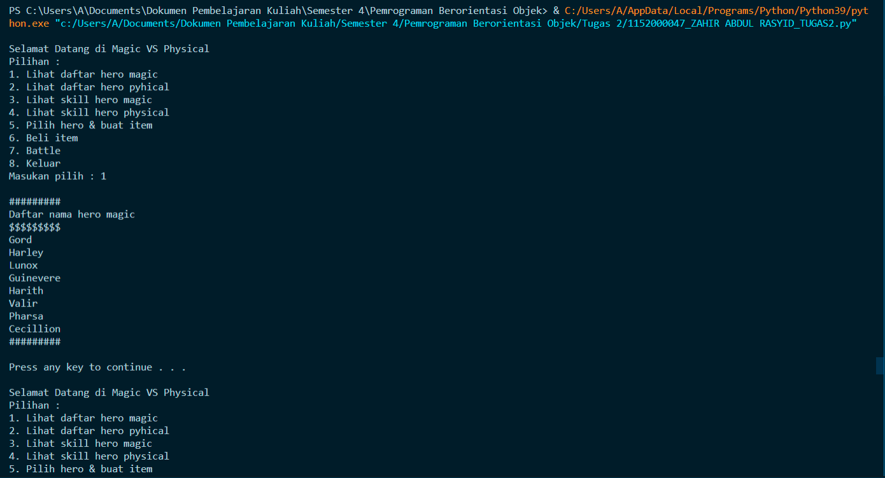

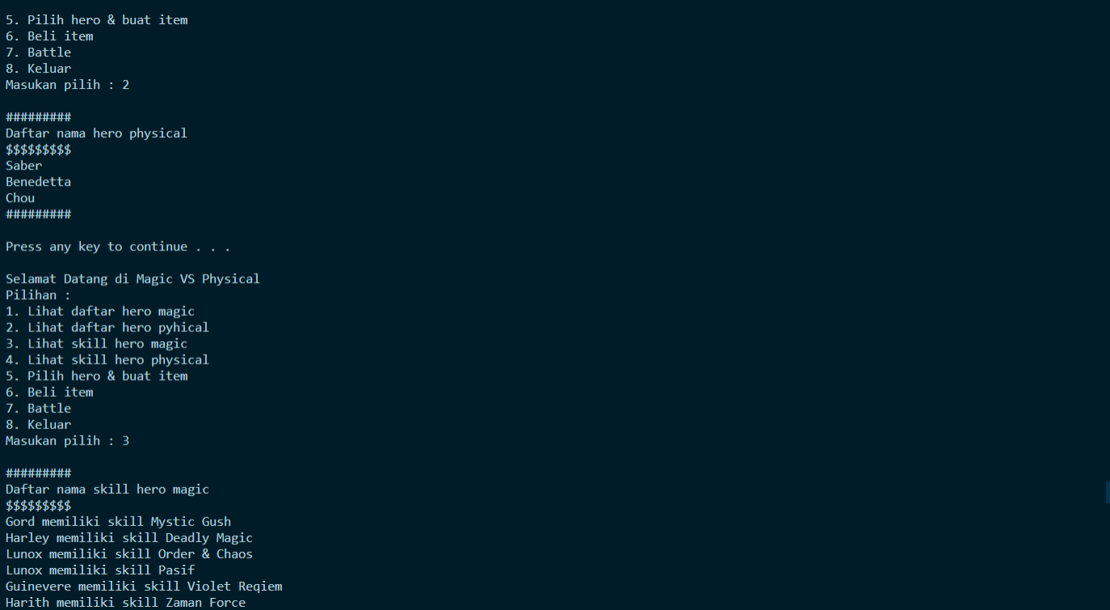

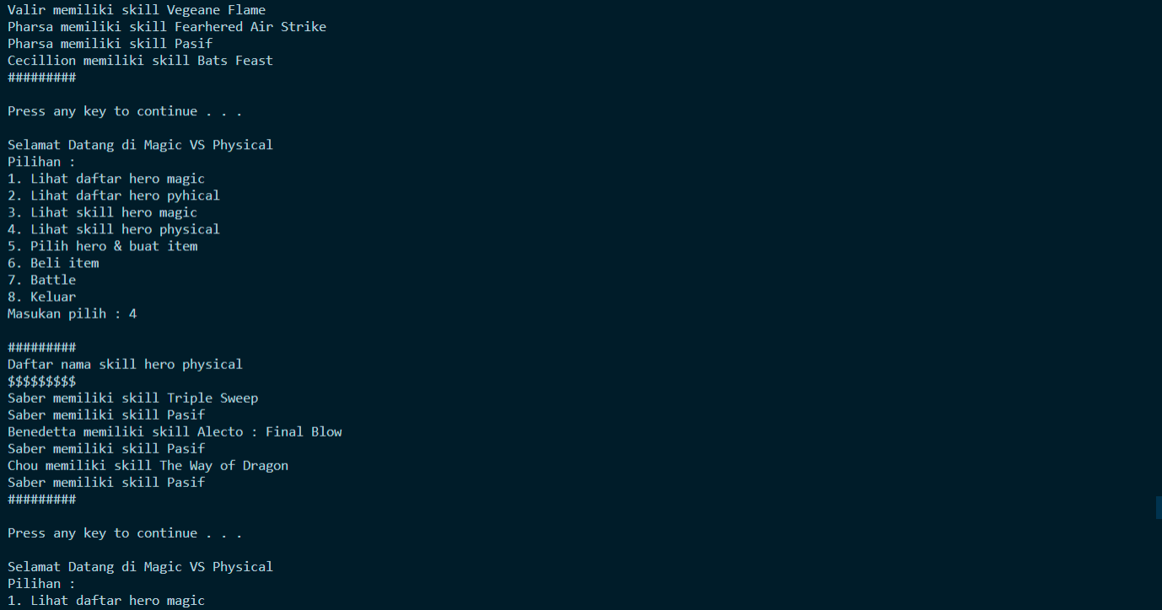

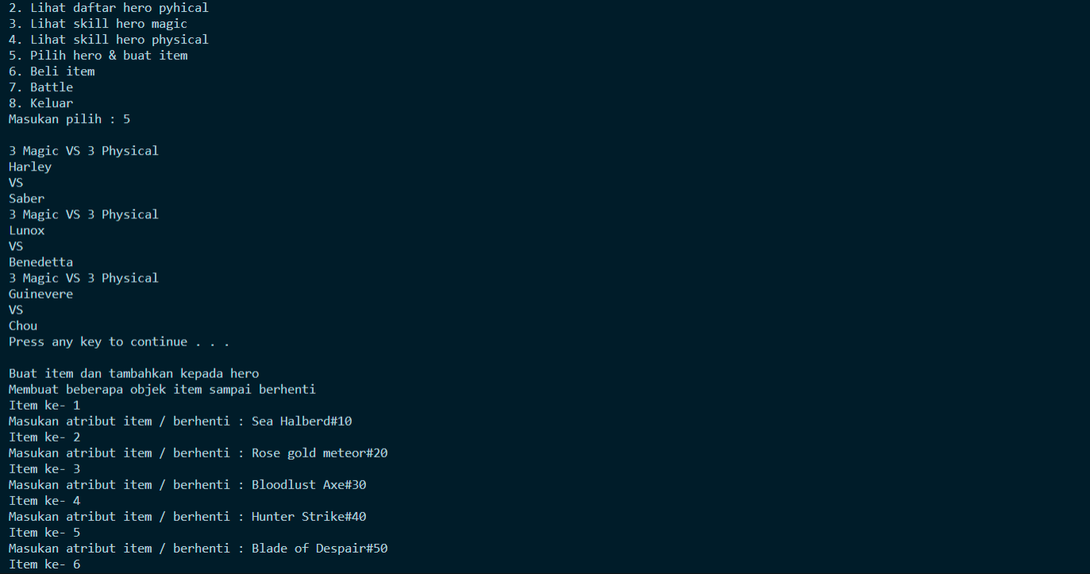

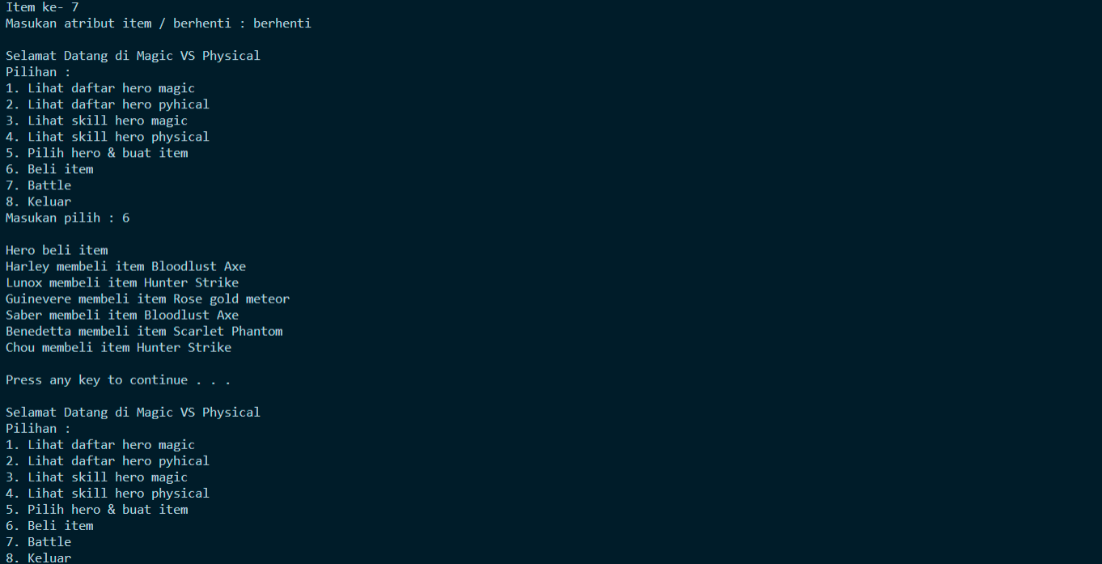

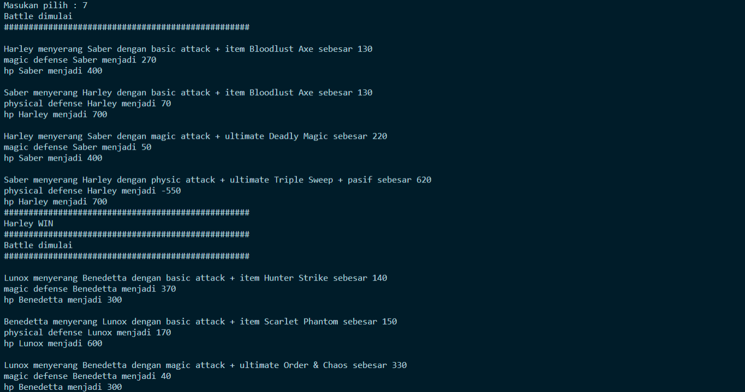

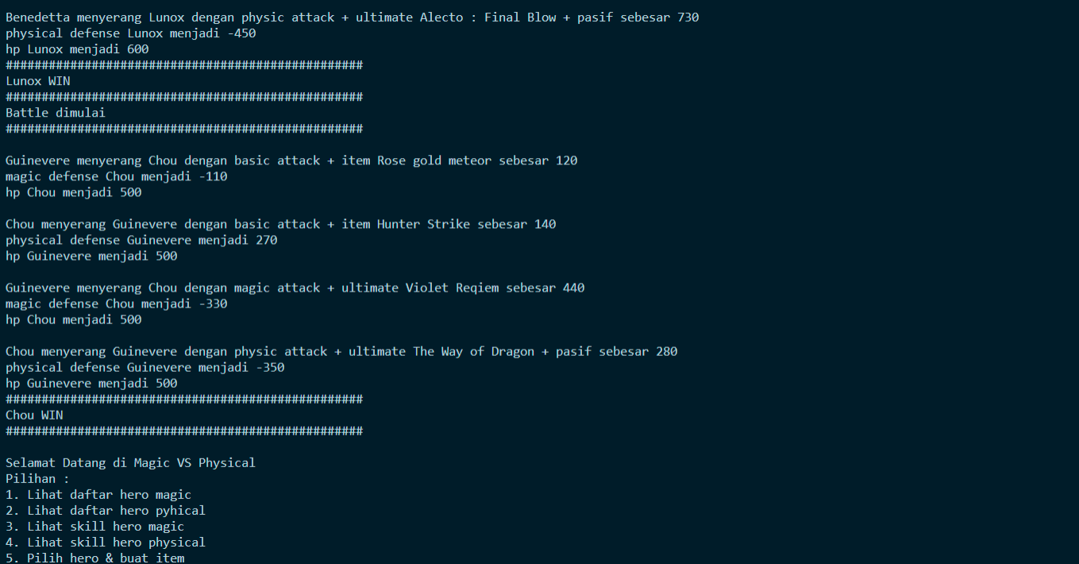



Keterangan Output Menu 7 (Battle):

# HARLEY VS SABER

|  |  |  |  |  |  |  |  |  |  |  |  |  |  |  |  |  |  |  |  |  |  |  |  |  |
| --- | --- | --- | --- | --- | --- | --- | --- | --- | --- | --- | --- | --- | --- | --- | --- | --- | --- | --- | --- | --- | --- | --- | --- | --- |
| **serang** | **Hero** | | |  | **Lawan** | | | | **BA** | **Item** | **Damage** | | | **Defense awal** | | | |  | **HP awal** | **Defense akhir** | | | | **HP akhir** |
| **1** |  | **Harley** |  |  |  | **Saber** | |  | **100** | **30** |  | **130** |  |  | **400** |  | |  | **400** |  |  | **270** | | **400** |
| **2** |  | **Saber** | |  |  | **Harley** |  | | **100** | **30** |  | **130** |  |  | **200** |  | |  | **700** |  | **70** | |  | **700** |
|  |  | | |  |  | | | |  |  |  | | |  | | | |  |  |  | | | |  |
| **serang** | **Hero** | | |  | **Lawan** | | | | **MA**  **/ PA** | **Ulti + Pasif** | **Damage** | | | **Defense awal +**  **skill** | | | |  | **HP awal** | **Defense akhir** | | | | **HP akhir** |
| **3** |  | **Harley** |  |  |  | **Saber** | |  | **200** | **20** |  | **220** |  |  | **270 + 20** | | |  | **400** |  |  | **50** | | **400** |
| **4** |  | **Saber** | |  |  | **Harley** |  | | **400** | **20 +**  **200** |  | **620** |  |  | **70 + 70** | |  |  | **700** |  | **-(550)** | | | **700** |
|  | |  |  |  | |
|  |  | | |  |  | | | |  |  |  | | |  | | | |  |  |  | | | |  |
|  | | | |  | | | | | |  | **Harley WIN** | | | | | | |  | |  | | | | |

# LUNOX VS BENEDETTA

|  |  |  |  |  |  |  |  |  |  |  |  |  |  |  |  |  |  |  |  |  |  |  |  |  |  |  |  |  |  |
| --- | --- | --- | --- | --- | --- | --- | --- | --- | --- | --- | --- | --- | --- | --- | --- | --- | --- | --- | --- | --- | --- | --- | --- | --- | --- | --- | --- | --- | --- |
| **serang** | | **Hero** | | |  | **Lawan** | | | | **BA** | | **Item** | | **Damage** | | | **Defense awal** | | |  | **HP awal** | | **Defense akhir** | | | | **HP akhir** | | |
| **1** | |  | **LUNOX** |  |  |  | **Bened** | |  | **100** | | **40** | |  | **140** |  |  | **500** |  |  | **300** | |  | **370** |  | | **300** | | |
| **2** | |  | **Bened** | |  |  | **LUNOX** |  | | **100** | | **50** | |  | **150** |  |  | **300** |  |  | **600** | |  | **170** |  | | **600** | | |
|  | |  | | |  |  | | | |  | |  | |  | | |  | | |  |  | |  | | | |  | | |
| **serang** | | **Hero** | | |  | **Lawan** | | | | **MA**  **/ PA** | | **Ulti + Pasif** | | **Damage** | | | **Defense awal +**  **skill** | | |  | **HP awal** | | **Defense akhir** | | | | **HP akhir** | | |
| **3** | |  | **Lunox** |  |  |  | **Bened** | |  | **300** | | **30 + 200** | |  | **530** |  |  | **370 + 15** | |  | **300** | |  | **40** | |  |  | **300** |  |
|  | **4** |  | **Bened** | |  |  | **Lunox** |  | |  | **500** |  | **30 + 200** |  | **730** | |  | 170 + 60 | |  |  | **600** |  | -(450) | | |  | **600** | |
|  | |  | | |  |  | | | |  | |  | |  | | |  | | |  |  | |  | | | |  | | |
|  | | | | |  | | | | | | |  | | **Lunox WIN** | | | | | |  | | |  | | | | | | |

# Guinevere VS CHOU

|  |  |  |  |  |  |  |  |  |  |  |  |  |  |  |  |  |  |  |  |  |  |  |  |  |  |  |  |  |  |
| --- | --- | --- | --- | --- | --- | --- | --- | --- | --- | --- | --- | --- | --- | --- | --- | --- | --- | --- | --- | --- | --- | --- | --- | --- | --- | --- | --- | --- | --- |
| **serang** | | **Hero** | | |  | **Lawan** | | |  | **BA** | | **Item** | | **Damage** | | | **Defense awal** | | | | **HP awal** | | **Defense akhir** | | | | **HP akhir** | | |
| **1** | |  | **Guin** | |  |  | **Chou** |  |  | **100** | | **20** | |  | **120** |  |  | **300** |  | | **500** | |  | **-** | **(110)** | | **500** | | |
| **2** | |  | **Chou** |  |  |  | **Guin** | |  | **100** | | **40** | |  | **140** |  |  | **700** |  | | **500** | |  | **270** |  | | **500** | | |
|  | |  | | |  |  | | |  |  | |  | |  | | |  | | | |  | |  | | | |  | | |
| **serang** | | **Hero** | | |  | **Lawan** | | |  | **MA**  **/ PA** | | **Ulti + Pasif** | | **Damage** | | | **Defense awal +**  **skill** | | | | **HP awal** | | **Defense akhir** | | | | **HP akhir** | | |
| **3** | |  | **Guin** | |  |  | **Chou** |  |  | **400** | | **40** | |  | **440** |  |  | **-(110) +20** | |  | **500** | | **-** | **330** | |  |  | **500** |  |
|  | |  |  |  | |  | |  |
|  | **4** |  | **Chou** |  |  |  | **Guin** | |  | **300** |  |  | **40 + 200** |  | **540** | |  | **270 + 50** | | |  | **500** |  | **-(350)** | | |  | **500** | |
|  | |  | | |  |  | | |  |  | |  | |  | | |  | | | |  | |  | | | |  | | |
|  | | | | |  | | | | **Chou WIN** | | | | | | | | | | | | | |  | | | | | | |